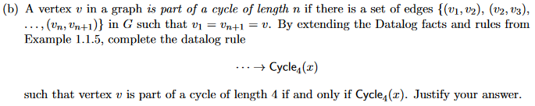Additional Exercises #2

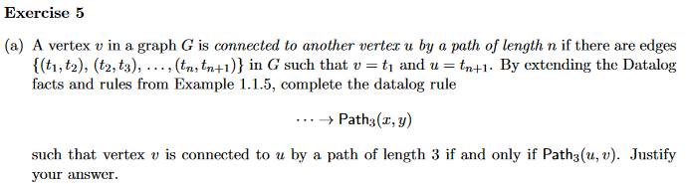

edge(v, t2) ^ edge(t2, t3) ^ edge(t3, u) → path(v, u)

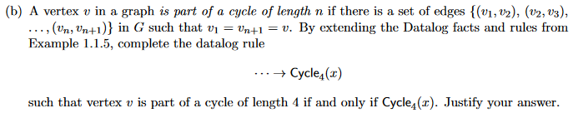

edge(v, v2) ^ edge(v2, v3) ^ edge(v3, v4), edge(v4, v) → path4(v, v)

path4(v, v) → cycle4(v)

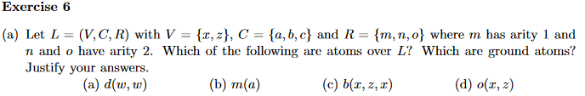

L - language

V - variables

C - constants

R - predicates